**Computer Vision Assignment 2 – Lane Detection (15%)**

**Due 19th April 2016**

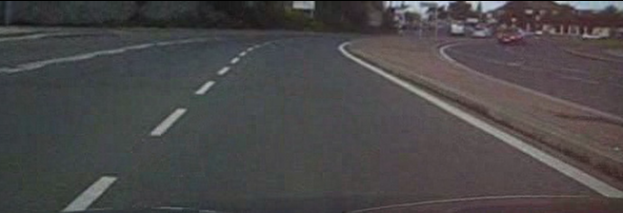

You are required to process a video from a vehicle mounted dashboard camera and detect the road lines for lane following applications

Here is what you have to do:

* Download the video from Moodle and have a look at it (convert to greyscale).
* Run an edge detector (use Canny but you can experiment with other) over the image using opencv to produce a binary image. You should experiment with the parameters to get a good edge image without too much noise
* Use the Hough transform in opencv to find the inside lines in the bottom half of the image.
* Try and use hough lines to follow the rest of the road line
* You should annotate the resulting image in colour to show where the road lines are.

Marks will be awarded for:

* Researching the opencv library functions (evidence of this as program comments) (20 marks)
* Creating a good edge binary image (20 marks)
* Finding the lines using the hough transform (20 marks)
* Using the hough line estimates to follow the rest of the road line (20 marks)
* Overall program and structure (20 marks)